SENDING A BANNER REPORT TO DATABASE

- When you are at the main menu page of Banner, enter the report name (such as SWRRTAC, FGRODTH, PZRBDIR) in the GO TO… field. This will take you to the ‘Process/Job Submission’ page of Banner (see below).

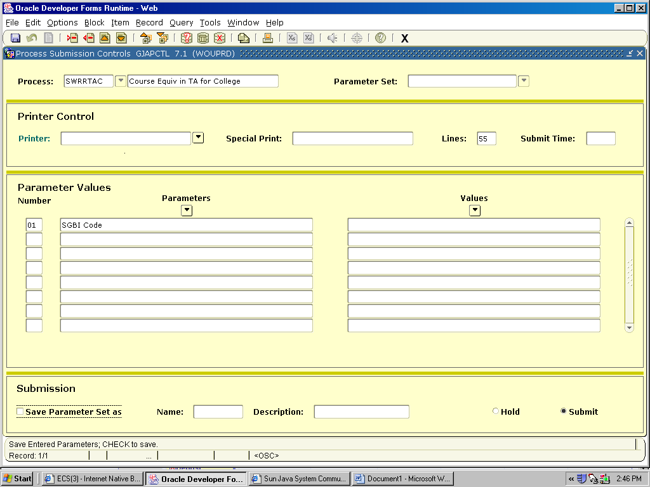

Page Down to the Printer field: and enter: DATABASE

Page Down to the Parameters and enter as necessary.

Page Down to the Submission block and SAVE (Click on Save parameter Set As if you wish). After you SAVE, note the file number at the bottom of the page.

- Now wait until the report is done running.
- OPTIONAL STEP: To check if it is done – Select Options in top toolbar – Select Review Job Status (GWIJOBR) and it will tell you if it is complete or not. You must use the Page Down key to ‘refresh’ the status on this page. Continue to Page Down until the report is completed. Exit this form once the job has completed.

TO IMPORT A BANNER TO IMPORT A BANNER REPORT TO EXCEL

A report has been submitted in Banner. While on the ‘Process/Job Submission’ page, select Options in the top toolbar and select Review Output (GJIREVO) and this will take you to the following form.
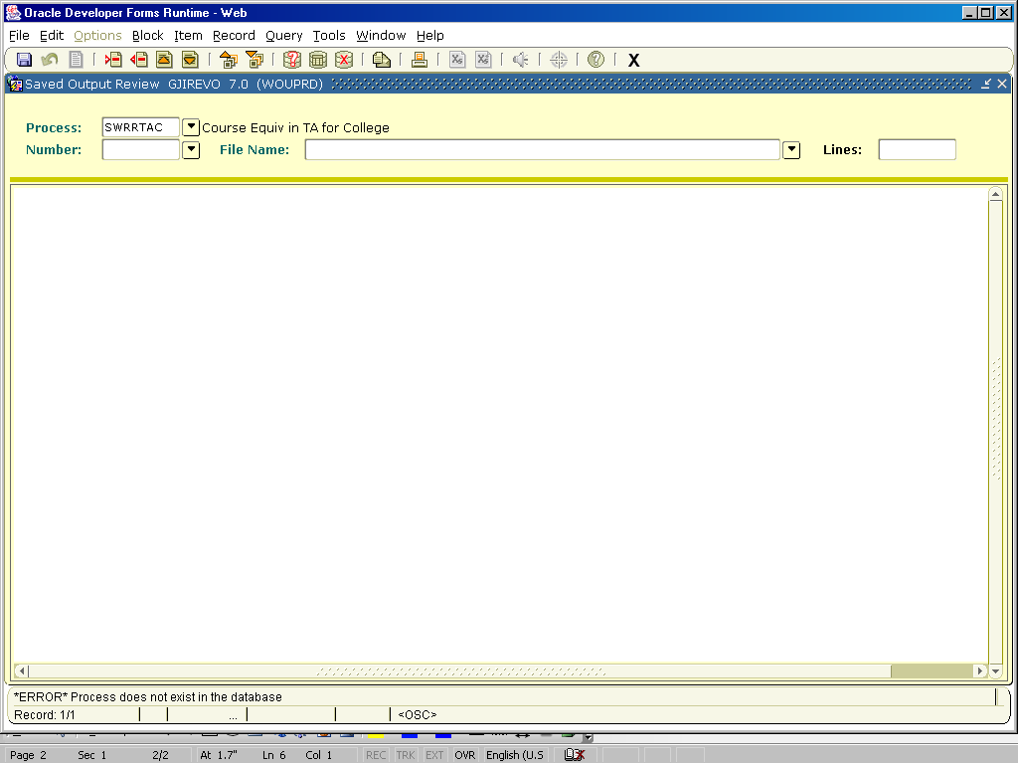

- Your job name should be listed in the Process: field
  - If Number is not already listed, click on the arrow next to the Number: field, find the .lis version of the report you are looking for, highlight it, then click OK.
  - If Number is already listed, tab to File Name: field, click on the arrow to find the .lis version of the report you are looking for, highlight it, then click OK.

- This will bring the report into the body of this page.

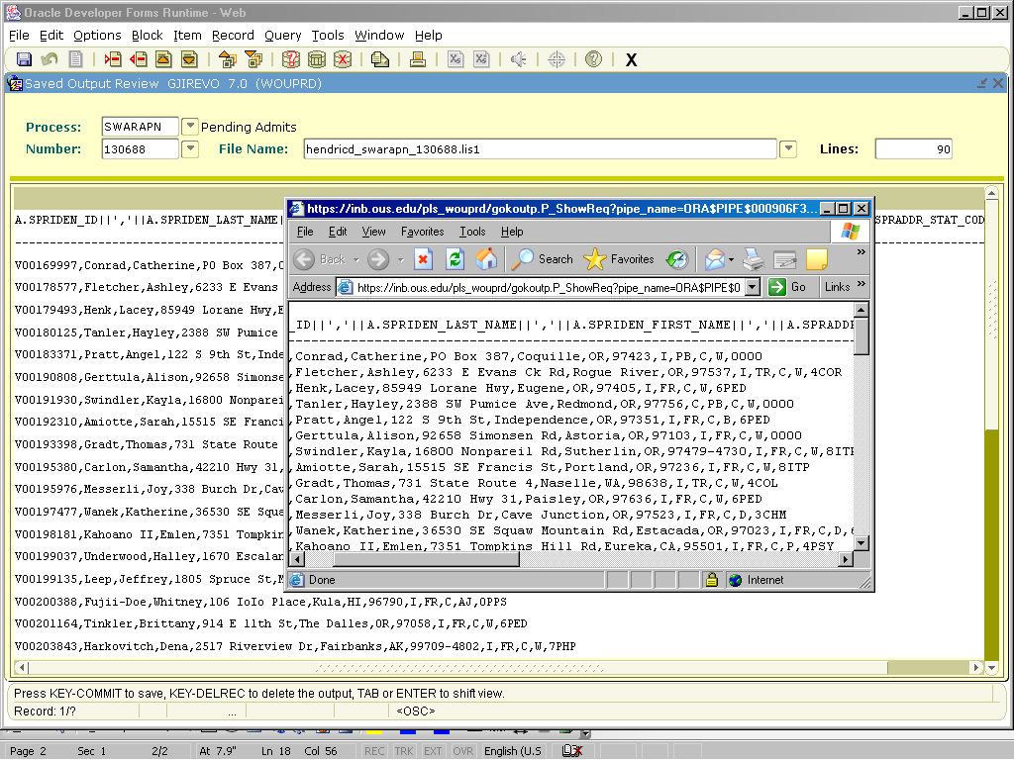
- Press F10. You will receive a pop-up message that says “You selected to Show File….Do you wish to continue?” – click on YES. This will bring up a web browser screen with the report in it.

- Open up an excel session

- Click in the web browser screen to put the cursor on that page,

- [CTRL + A] to select all

- [CTRL + C] to copy all

- Click the cursor in the first cell in excel (this is the A1 cell)

- [CTRL + V] to paste the information into excel

- Highlight your column

- Select Data Menu

- Select Text to Column follow prompts

- Close original web browser screen

