**Informational Interviewing WOU – SLCD**

One of the best sources for gathering information about what's happening in an occupation or an industry is to talk to people working in the field. This process is called informational or research interviewing. An informational interview is an interview that **you** initiate - you ask the questions. The purpose is to obtain information, not to get a job.

**Following are some good REASONS TO CONDUCT INFORMATIONAL INTERVIEWS**:

* to explore careers and clarify your career goal
* to discover employment opportunities that are not advertised
* to expand your professional network
* to build confidence for your job interviews
* to access the most up-to-date career information
* to identify your professional strengths and weaknesses

**Listed below are STEPS TO FOLLOW TO CONDUCT AN INFORMATIONAL INTERVIEW:**

1. **Identify the Occupation or Industry You Wish to Learn About**   
   Assess your own interests, abilities, values, and skills, and evaluate labor conditions and trends to identify the best fields to research.
2. **Prepare for the Interview**

Read all you can about the field prior to the interview. Decide what information you would like to obtain about the occupation/industry. Prepare a list of questions that you would like to have answered.

1. **Identify People to Interview**

Start with lists of people you already know - friends, relatives, fellow students, present or former co-workers, supervisors, neighbors, etc... Professional organizations, the yellow pages, organizational directories, and public speakers are also good resources. You may also call an organization and ask for the name of the person by job title.

1. **Arrange the Interview**

Contact the person to set up an interview:

* + by telephone,
  + by an email followed by a telephone call, or
  + by having someone who knows the person make the appointment for you.

1. **Sample script for asking for an informational interview  
   *“Dear Mr. Song, my name is Rachel Shift, and I’m a third year Computer Science student at WOU. I’m contacting you because I’m very interested in pursuing a career in game design and I was referred to you by Dr. Dell, as someone who is very successful in their field. Would you have about 15 minutes to meet with me so I can learn a little about your career path? I’m looking for some guidance and suggestions on how best to prepare for a career in this competitive field.***

Service Learning & Career Development

WUC 119 ~ www.wou.edu/slcd

503-838-8432 ~ slcd@wou.edu

www.wou.edu/wolflink

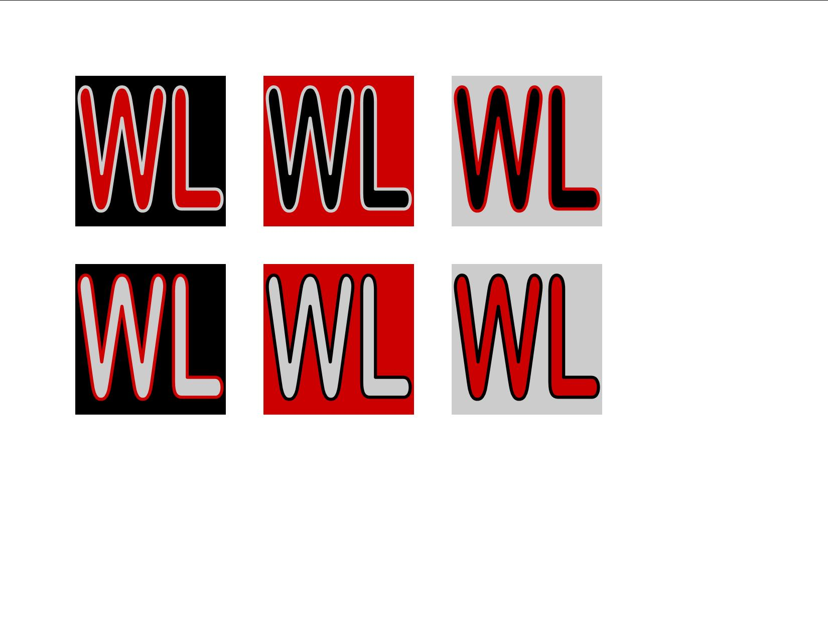

1. **Conduct the Interview**

Dress appropriately, arrive on time, be polite and professional. Refer to your list of prepared questions; stay on track, but allow for spontaneous discussion. Before leaving, ask your contact to suggest names of others who might be helpful to you and ask permission to use your contact's name when contacting these new contacts.

1. **Follow Up**

Immediately following the interview, record the information gathered. Be sure to send a thank-you note to your contact within one week of the interview.

**NOTE: Always analyze the information you've gathered. Adjust your job search, resume, and career objective if necessary.**

# 20 QUESTIONS for an Informational Interview:

Prepare a list of your own questions for your informational interview. Following are some sample questions:

1. On a typical day in this position, what do you do?
2. What training or education is required for this type of work?
3. What personal qualities or abilities are important to being successful in this job?
4. What part of this job do you find most satisfying? most challenging?
5. How did you get your job?
6. What opportunities for advancement are there in this field?
7. What entry level jobs are best for learning as much as possible?
8. What are the salary ranges for various levels in this field?
9. How do you see jobs in this field changing in the future?
10. Is there a demand for people in this occupation?
11. What special advice would you give a person entering this field?
12. What types of training do companies offer persons entering this field?
13. What are the basic prerequisites for jobs in this field?
14. Which professional journals and organizations would help me learn more about this field?
15. What do you think of the experience I've had so far in terms of entering this field?
16. From your perspective, what are the problems you see working in this field?
17. If you could do things all over again, would you choose the same path for yourself? Why? What would you change?
18. With the information you have about my education, skills, and experience, what other fields or jobs would you suggest I research further before I make a final decision?
19. What do you think of my resume? Do you see any problem areas? How would you suggest I change it?
20. Who do you know that I should talk to next? When I call him/her, may I use your name?