**Website Structure**

Please read through this document and fill out the areas that apply to your website. Send it to [gauntzd@wou.edu](mailto:gauntzd@wou.edu) when completed and a new WordPress website will be setup for you.

Here is a link to a demo site: <http://www.wou.edu/demo/>

Here is a link to the Art Department’s new site that is still under construction but can give you an idea: <http://www.wou.edu/artdepartment/>

**Top navigation**

You can have up to 7 items as long as they fit on one line. It is required to have either a “Degrees & Programs” tab (for academic departments) a “Services” tab (for administrative departments). Every site will also be required to have a “People” tab.

**Examples**







|  |  |  |  |  |  |  |
| --- | --- | --- | --- | --- | --- | --- |
| Tab 1 | Tab 2 | Tab 3 | Tab 4 | Tab 5 | Tab 6 | Tab 7 |

|  |  |  |  |  |  |  |
| --- | --- | --- | --- | --- | --- | --- |
| Degrees & Programs  or  Services | *Enter tab name here (optional)* | *Enter tab name here (optional)* | *Enter tab name here (optional)* | *Enter tab name here (optional)* | *Enter tab name here (optional)* | People |

**Dropdown for tab 1 (optional)**

|  |  |  |
| --- | --- | --- |
| *List of pages*  *or*  *Leave blank* | *List of pages*  *or*  *Callout message*  *or*  *Leave blank* | *List of pages*  *or*  *Callout message*  *or*  *Leave blank* |

**Dropdown for tab 2 (optional)**

|  |  |  |
| --- | --- | --- |
| *List of pages*  *or*  *Leave blank* | *List of pages*  *or*  *Callout message*  *or*  *Leave blank* | *List of pages*  *or*  *Callout message*  *or*  *Leave blank* |

**Dropdown for tab 3 (optional)**

|  |  |  |
| --- | --- | --- |
| *List of pages*  *or*  *Leave blank* | *List of pages*  *or*  *Callout message*  *or*  *Leave blank* | *List of pages*  *or*  *Callout message*  *or*  *Leave blank* |

**Dropdown for tab 4 (optional)**

|  |  |  |
| --- | --- | --- |
| *List of pages*  *or*  *Leave blank* | *List of pages*  *or*  *Callout message*  *or*  *Leave blank* | *List of pages*  *or*  *Callout message*  *or*  *Leave blank* |

**Dropdown for tab 5 (optional)**

|  |  |  |
| --- | --- | --- |
| *List of pages*  *or*  *Leave blank* | *List of pages*  *or*  *Callout message*  *or*  *Leave blank* | *List of pages*  *or*  *Callout message*  *or*  *Leave blank* |

**Dropdown for tab 6 (optional)**

|  |  |  |
| --- | --- | --- |
| *List of pages*  *or*  *Leave blank* | *List of pages*  *or*  *Callout message*  *or*  *Leave blank* | *List of pages*  *or*  *Callout message*  *or*  *Leave blank* |

**Left navigation**

**Options:**

* No left navigation
* Same left navigation on all internal pages (max 8 items)
* Different left navigation on different page groups (a page group is determined by the tab it is under – 8 max)

**Examples**

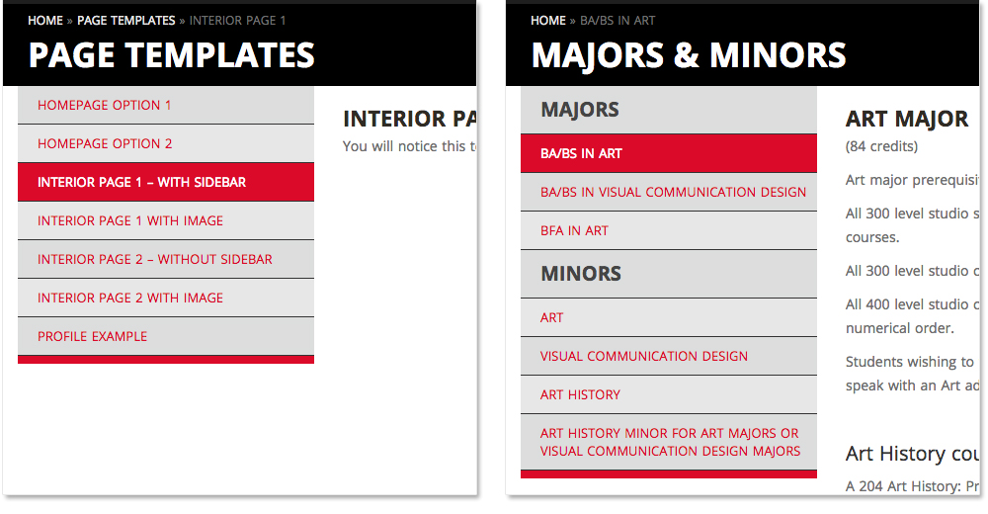

|  |  |  |
| --- | --- | --- |
| **All Pages – Same left navigation**  *List of pages*  *(Leave blank if you don’t want left navigation)* |  |  |

|  |  |  |
| --- | --- | --- |
| **Tab 1 Pages – Left navigation**  *List of pages*  *(Leave blank if you don’t want left navigation)* | **Tab 2 Pages – Left navigation**  *List of pages*  *(Leave blank if you don’t want left navigation)* | **Tab 3 Pages – Left navigation**  *List of pages*  *(Leave blank if you don’t want left navigation)* |

|  |  |  |
| --- | --- | --- |
| **Tab 4 Pages – Left navigation**  *List of pages*  *(Leave blank if you don’t want left navigation)* | **Tab 5 Pages – Left navigation**  *List of pages*  *(Leave blank if you don’t want left navigation)* | **Tab 6 Pages – Left navigation**  *List of pages*  *(Leave blank if you don’t want left navigation)* |